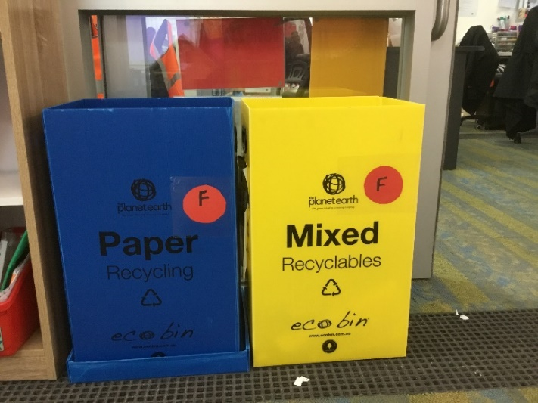
Reducing Waste at Meadows Primary in 2019

Meadows Primary School is working very hard to reduce its impact on the environment.

So many of our wonderful Green Team students care deeply for the environment and lead the way with recycling.

Our goal is to reduce our current landfill and costs by half or more.

We have changed landfill skip pickups from weekly to fortnightly.

We found that with all the recycling the school does, the landfill skip was not full when it was picked up and was a waste of money.

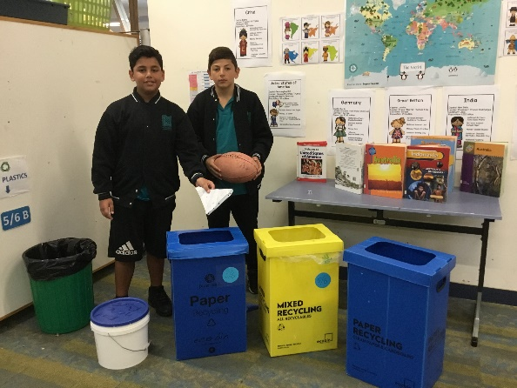
We recycle paper and cardboard.

We have mixed recycling-we recycle things like foil, juice boxes, tin cans plastic bottles and containers.

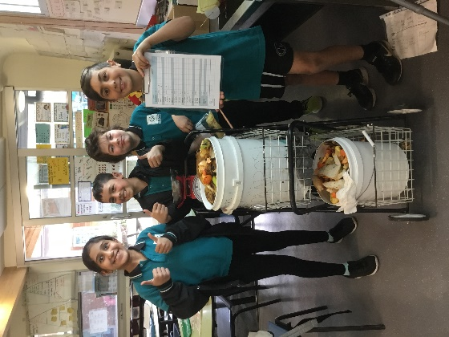

We enjoy collecting food scraps.

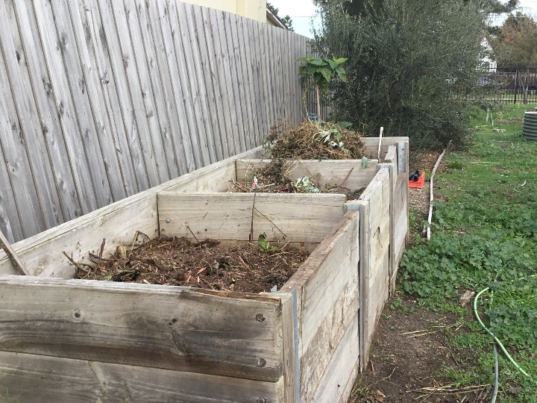

Then composting into our large composting bays in the community garden.
Our food scraps will make rich humus (rich soil) for our garden.

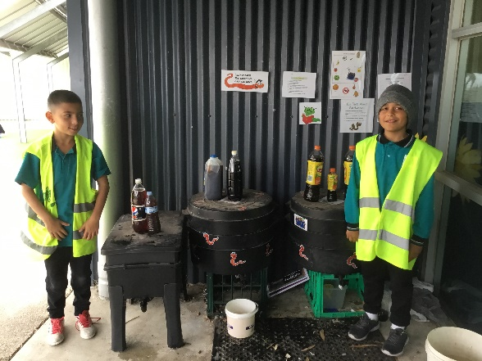

We have 6 worm farms that we feed and collect worm juice to feed our plants.

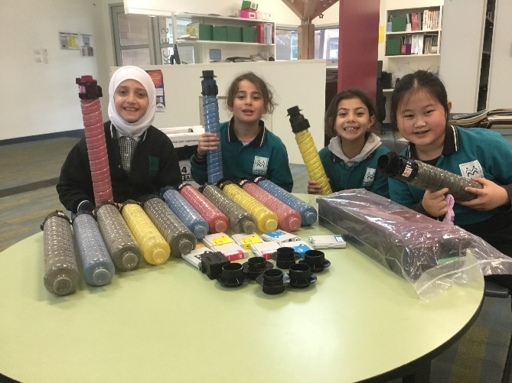

We are good at recycling Printer Cartridges.

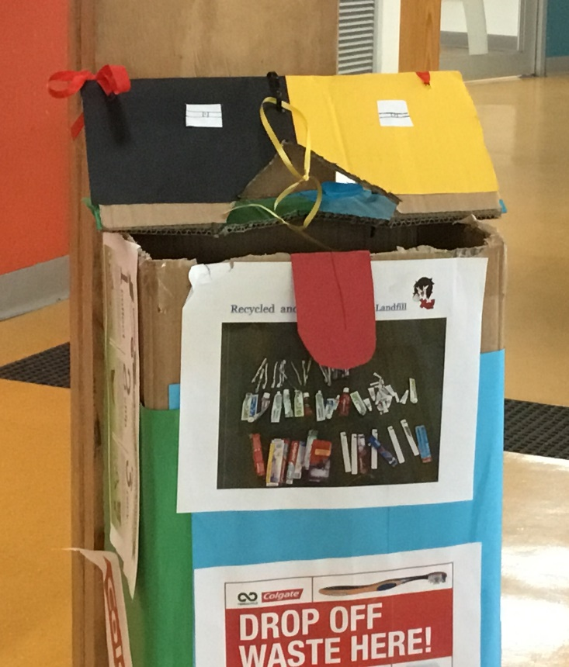

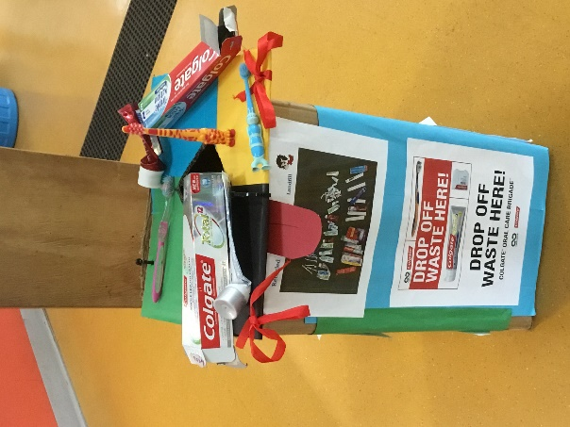
We love to recycle Oral Care- toothbrushes, toothpaste and packaging.

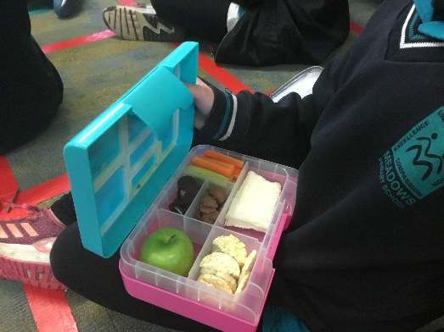
We have Rubbish Free Lunches on Friday’s.

The winning class with the most Rubbish free lunches get to have the turtle and fish for the week.
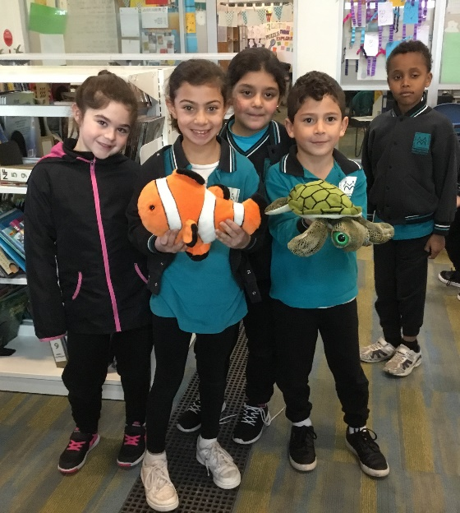
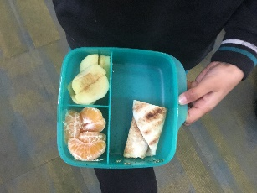

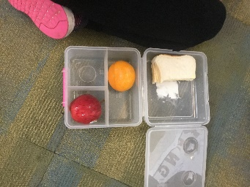

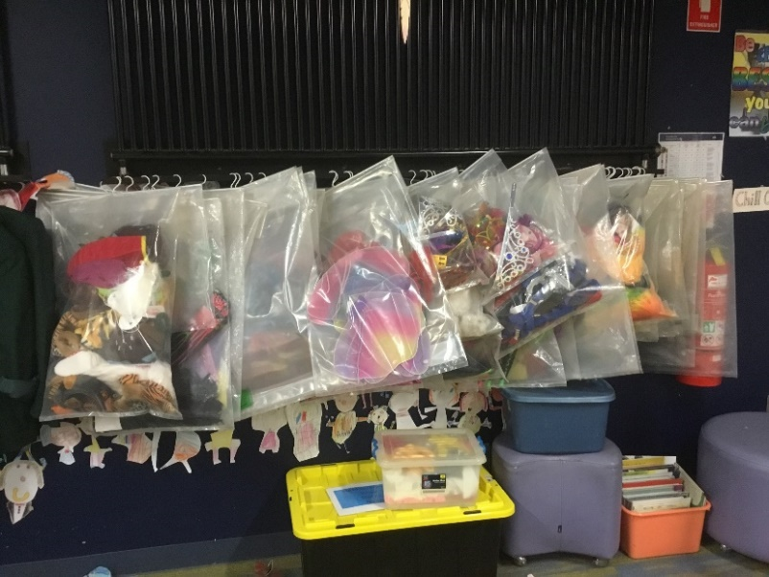

We also repurpose things like big book bags, they become costume and prop bags for the Performing Arts Class.

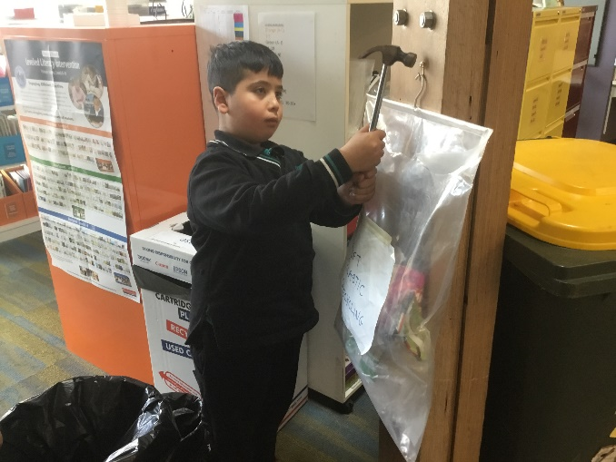

Also the big book bags are used for collecting soft plastics in the classroom .

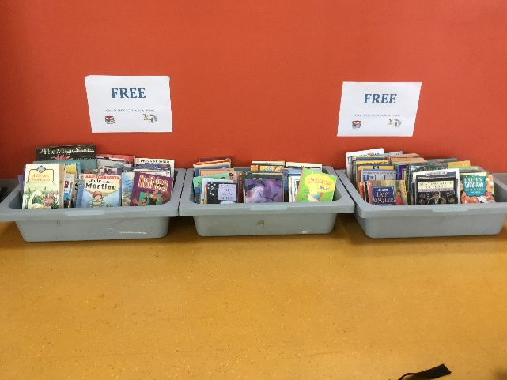
.

Books are shared with the school community

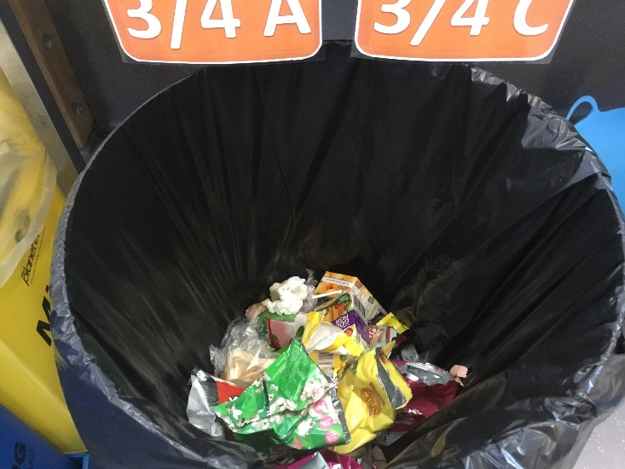

We share landfill bins between two classes

We also encourage the school community to recycle.
We have designated collection boxes for the recycled products.
Students use these recycled products in their learning.

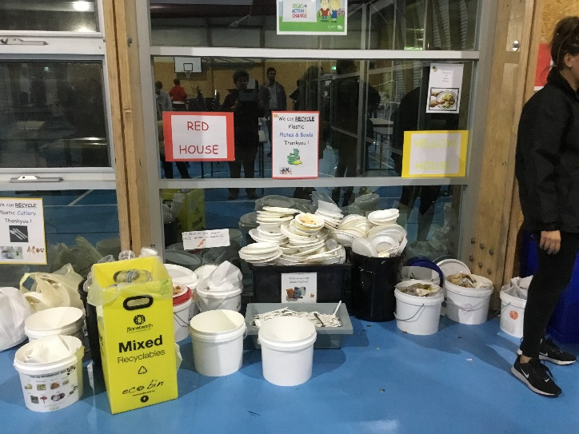
At this year’s Community Iftar Dinner of 300 people, there was a focus on being Sustainable. We shared with the community our great recycling, all of our standard recycling of paper, mixed recycling and composting. In addition, plastics- cups, plates, bowls and cutlery.

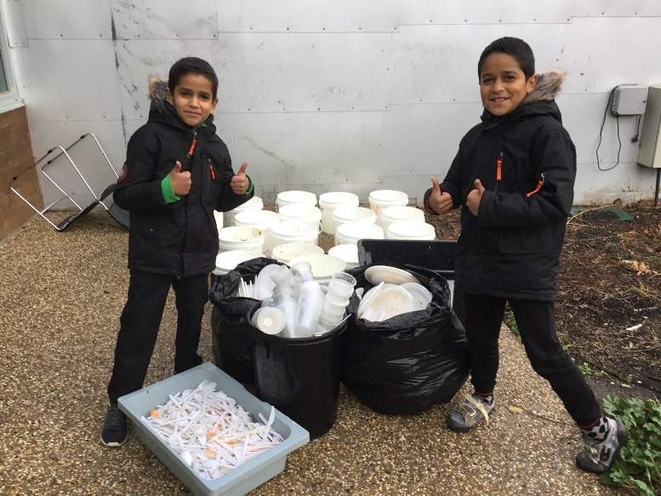

Our Amazing Green Team washed, sanitized, dried and packed away all the plastics, for our next school event.

