Meadows PS Biodiversity Learning Story
The Biodiversity module has been a particular focus of the student sustainability group over the last 4 years. The student Sustainability team began auditing in 2015, and we continue to audit every year and have slowly increased our Habitat Assessment Quality score.
Biodiversity officer Mel from Hume Council and Meadows garden specialist/horticulturalist Elissa, have identified that improvements were needed to the understorey from the biodiversity audits. Through the Seedlings for Schools program supported by Hume Council, we have continued to add native and indigenous species groundcovers, shrubs and plants that will attract native animals, creatures and birds.
Our Green Team uses the knowledge they have gained on native plants to complete the audit. They identify the native animals, creatures and birds that use our school grounds as refuge and food source, and devise ways to encourage more native fauna to our school. Our planting regime so far encourages native animals, birds and insects to our school grounds.
Our student Bird Club in conjunction with Hume Mens Shed, have designed and are helping to construct some physical structures such as bee hotels, birdhouses and bird baths.
We hope that the addition of these new homes will see a boost in the number of native fauna that visit and shelter in our school.
Our grade 5/6 students are participating in the Zoos Victoria Fighting Extinction Program to learn about how to save endangered wildlife locally and around the world.
One such habitat we are trying to create at Meadows is a frog bog that will help to attract an endangered species that was once abundant many years ago. It was one of the most common frogs in south-eastern Australia but has suffered a substantial decline in recent years and is called the Growling Grass Frog.
Over the last 2 weeks students from Foundation to Grade 6 have started planting out a special frog habitat in the swale of our Community Garden. The bog was planted with grasses such as Common Sedge and Knobbly Club Rush. Around the pond edge we created lots of places for frogs to hide using leaf mulch and groundcovers like ruby saltbush and strappy plants like Common Sedge, Knobbly Club Rush and Basalt Daisies which flower late winter to spring, and will attract insects that the frogs love to eat.
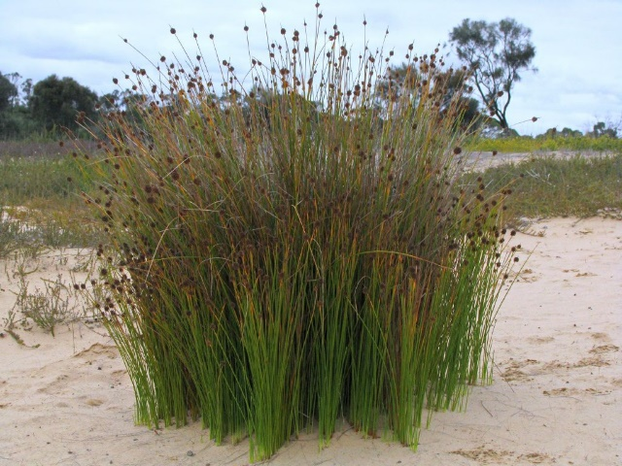
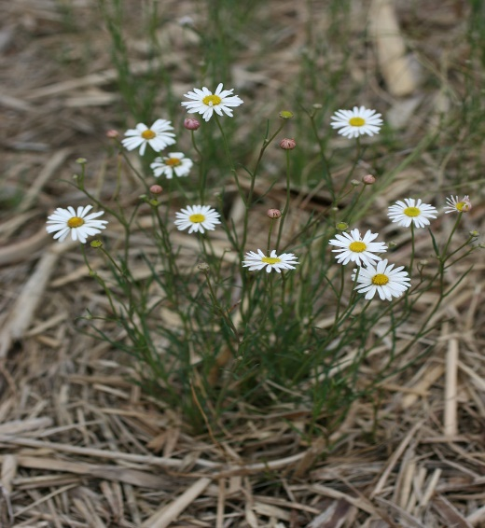

Knobbly Club Rush
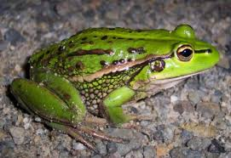
Basalt daisy

Growling Grass Frog
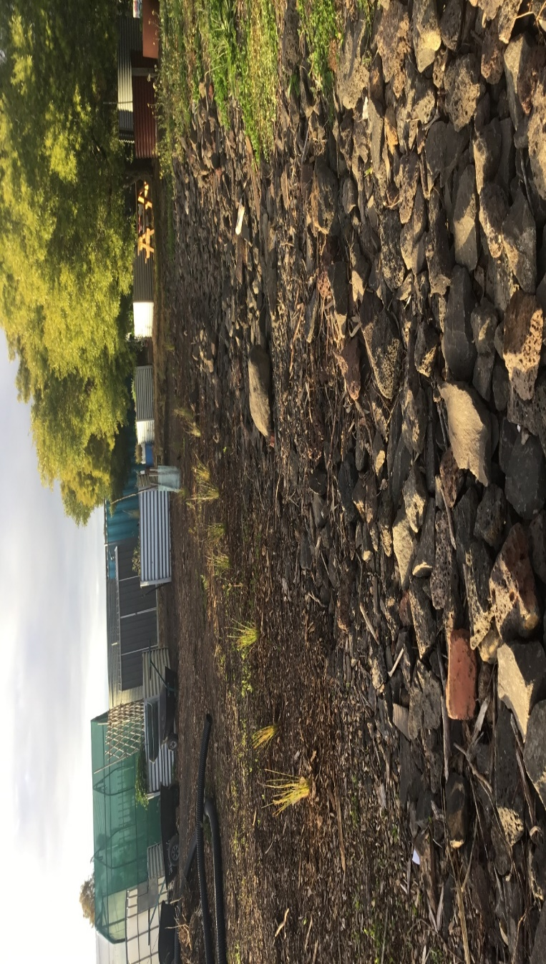
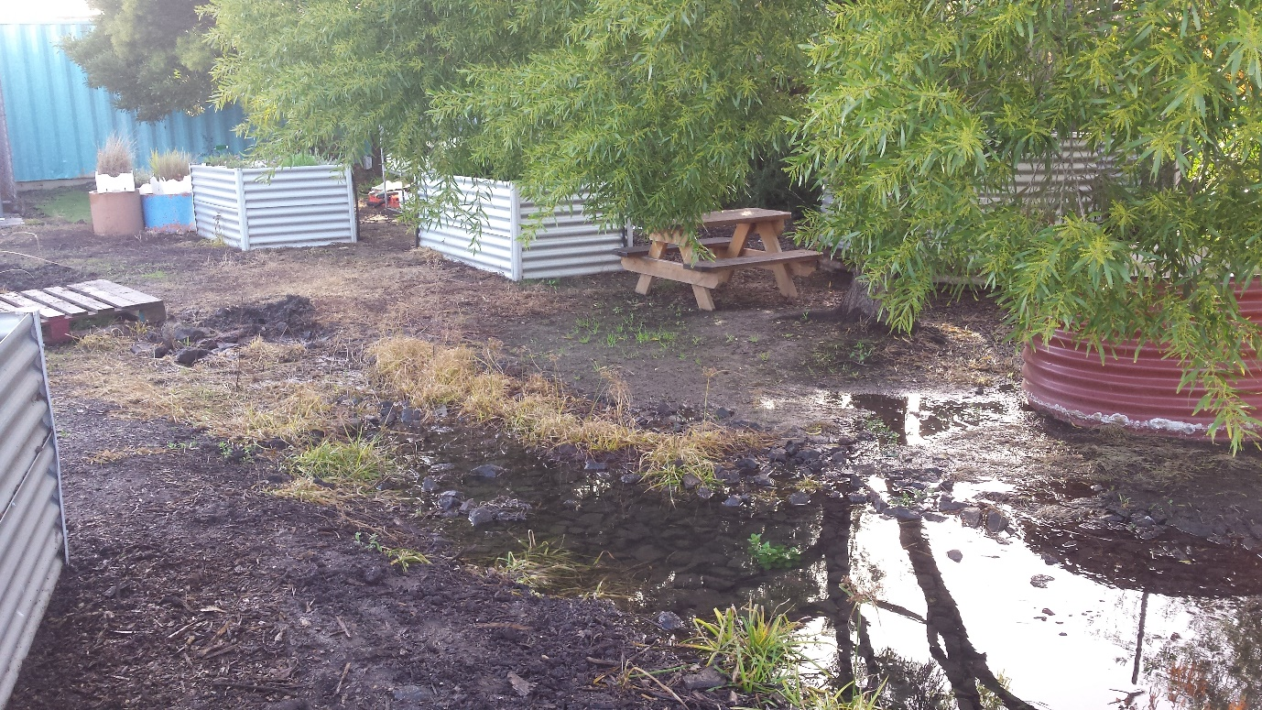
AFTER
BEFORE

AFTER

Some thoughts and reflections of Grade 1 and 2 students after their planting sessions.

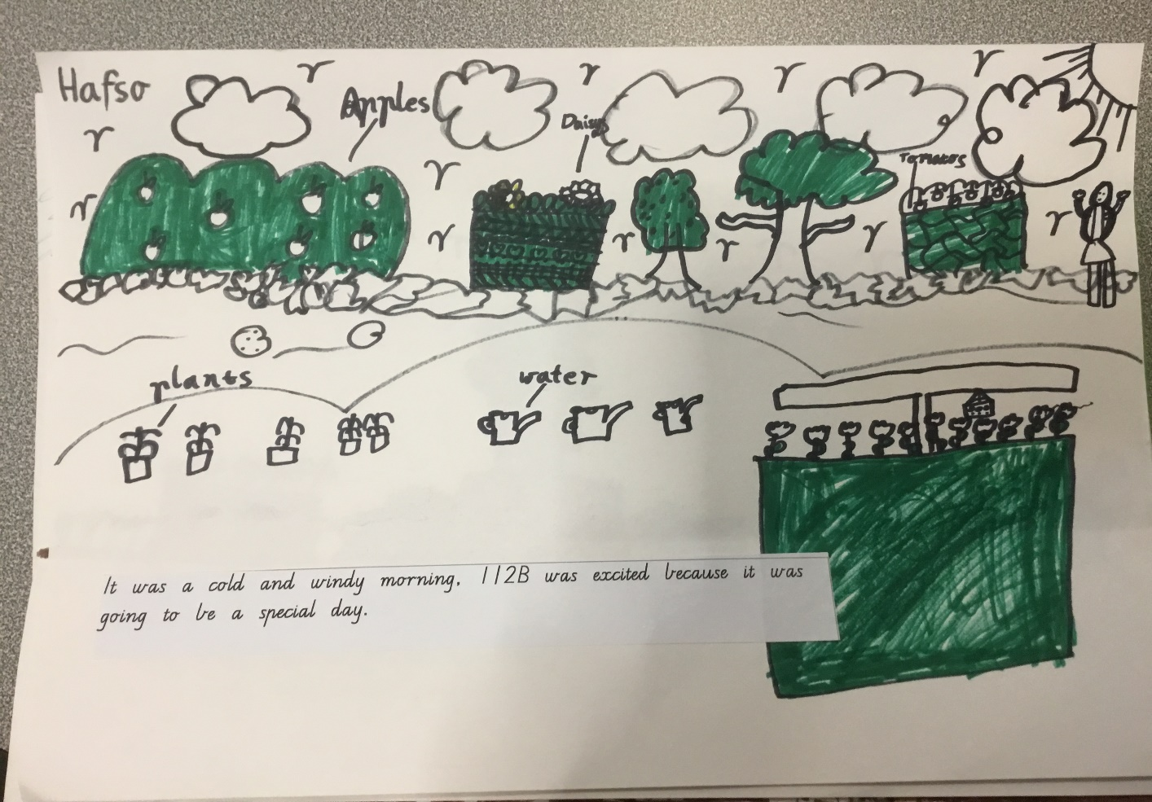

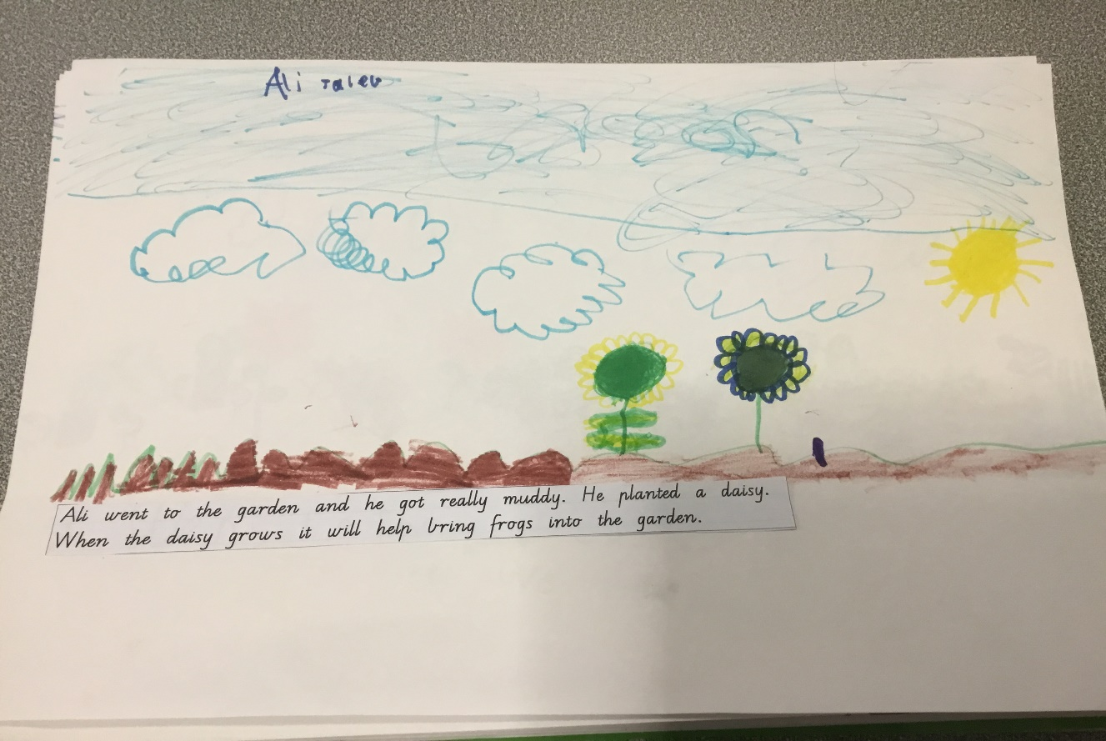

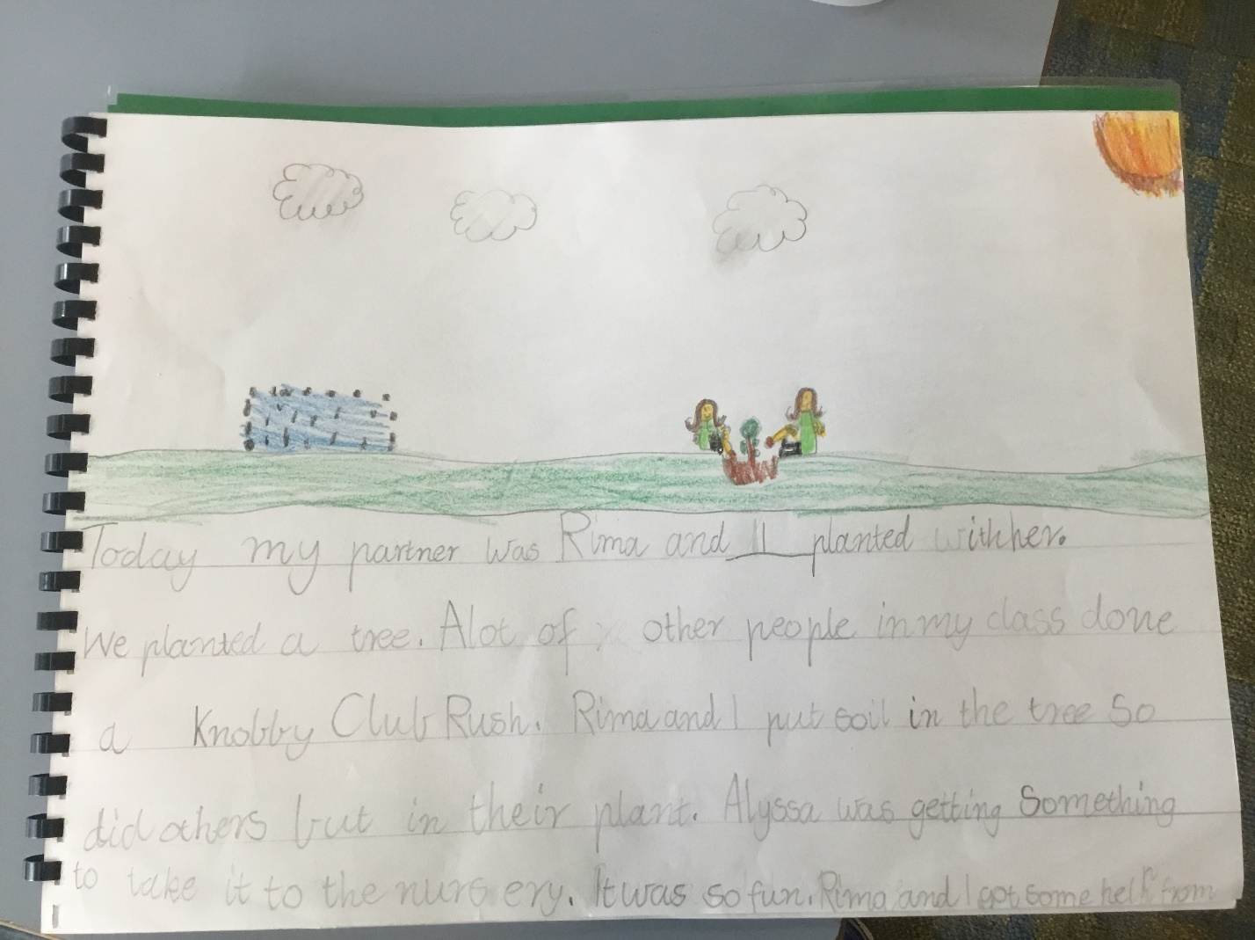

Page 1
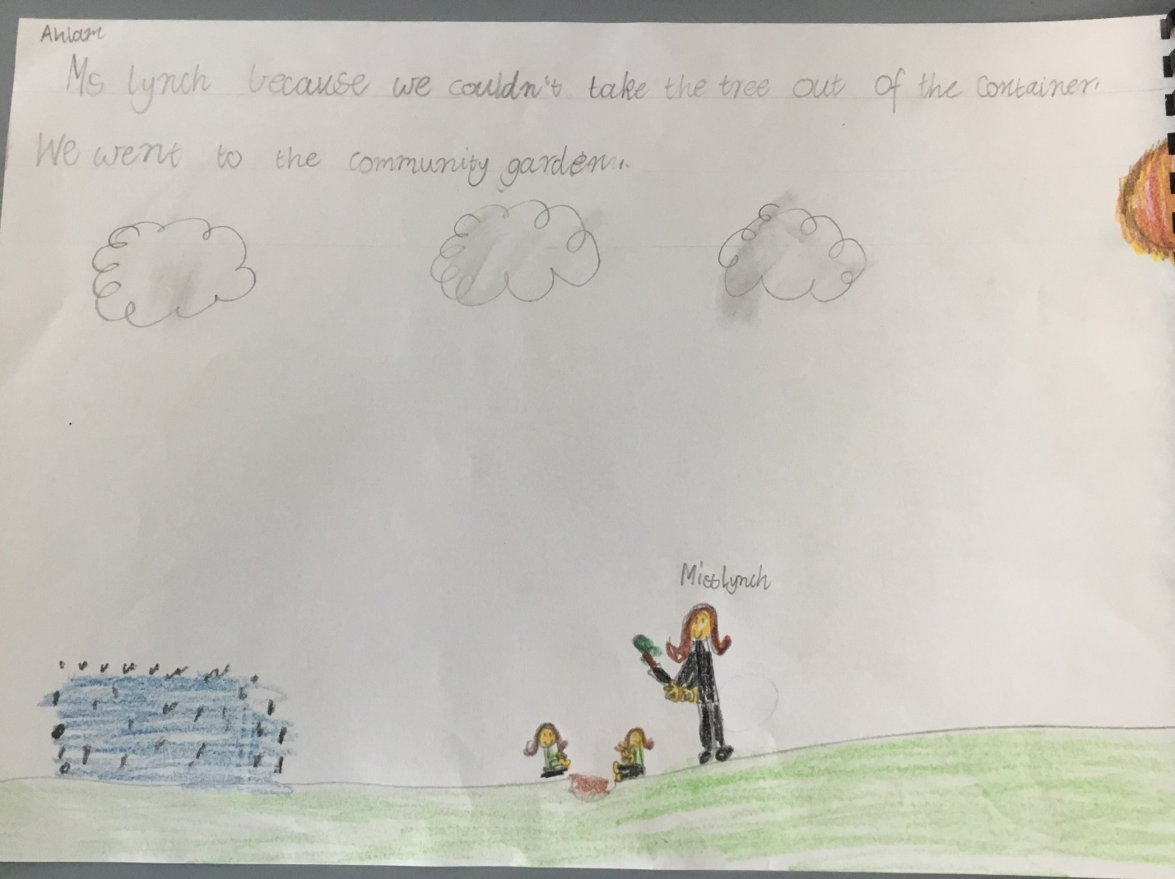

Page 2
