**2018 Beginning our biodiversity journey at Cranbourne East Primary school.**

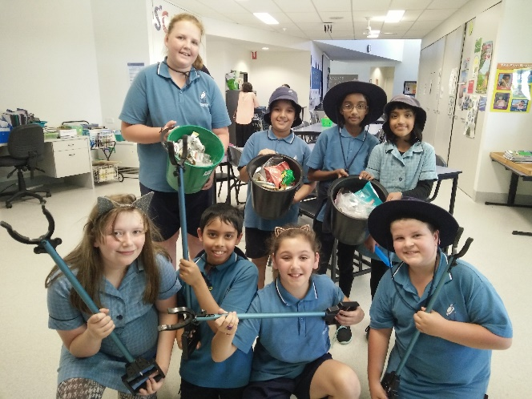There’s no shortage of enthusiastic ‘rubbish picking up’ volunteers at break times.

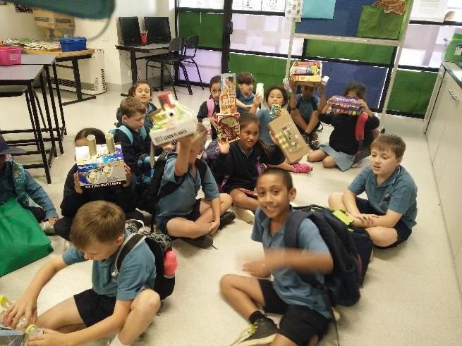

Year 2 creators made machines out of recycled materials.

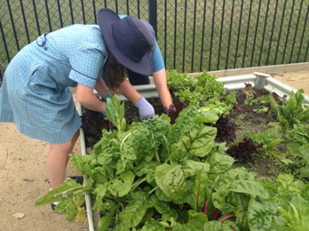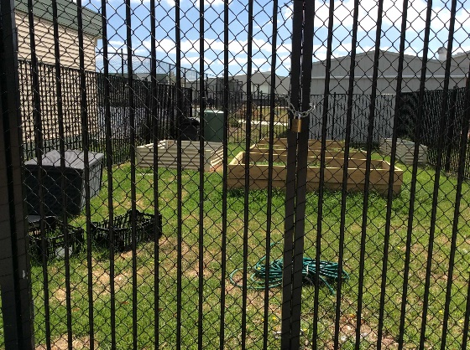

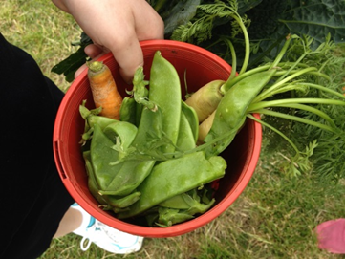

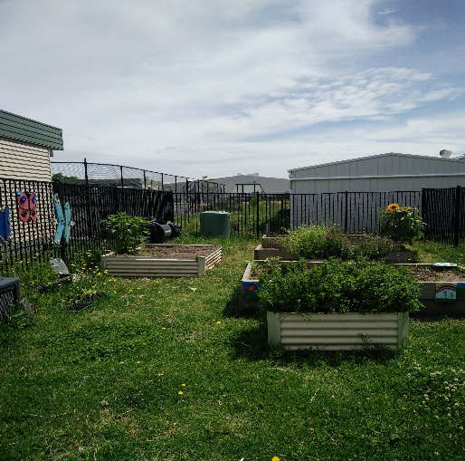

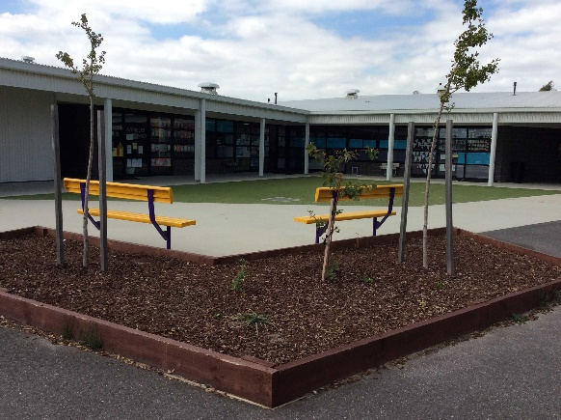

Our vegetable garden started off fresh in 2017, grew many vegetables that we could sell to our community and now has some early flowering sunflowers still.

New garden bed and friendship chairs.

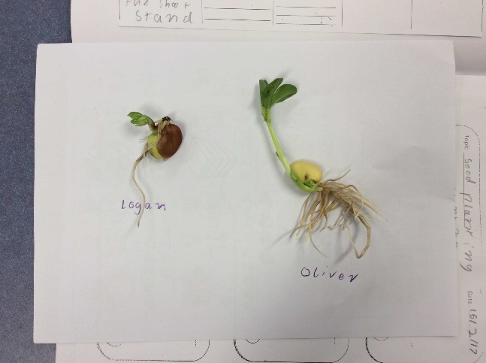

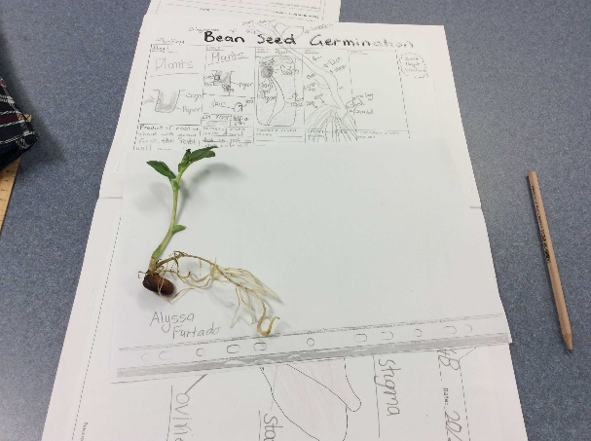

Our beans grew well in class.

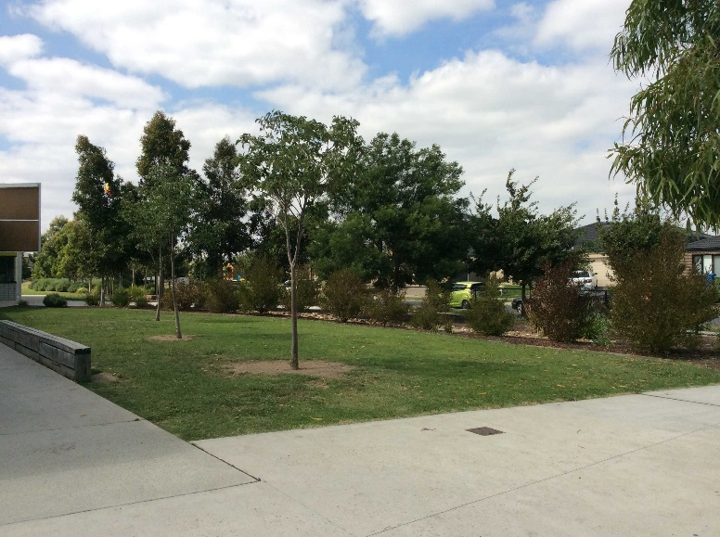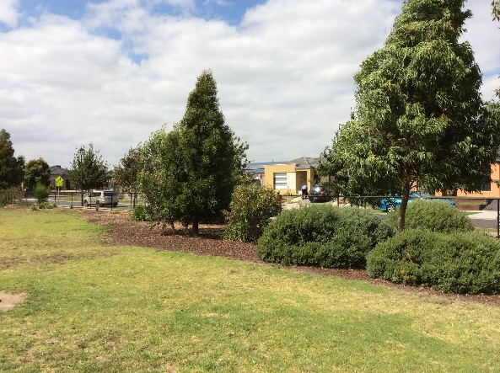

Front treed area of school growing well because it’s out of bounds as a play area.

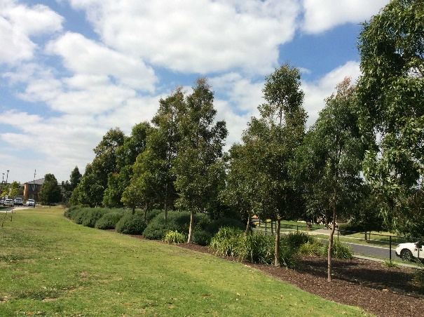

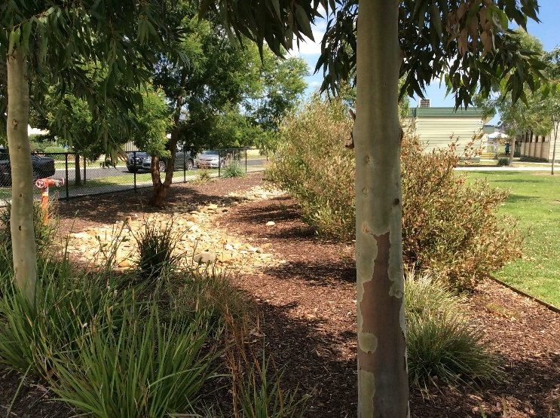

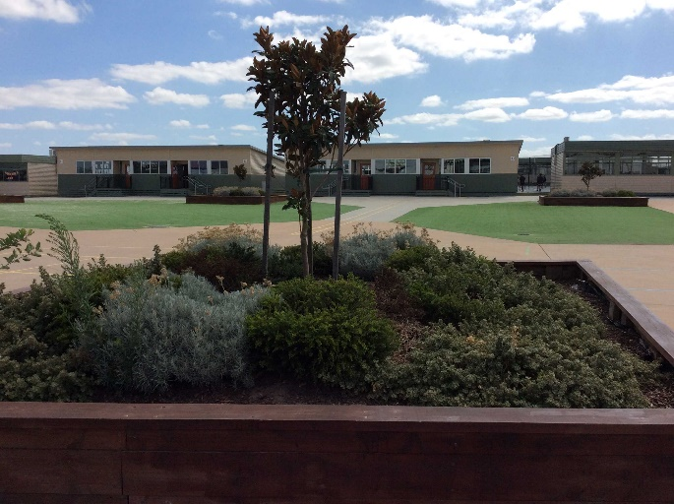

Front of school dry riverbed shaded view.

Agora area garden beds

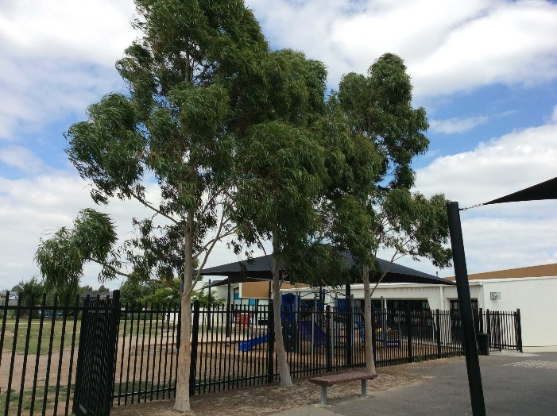

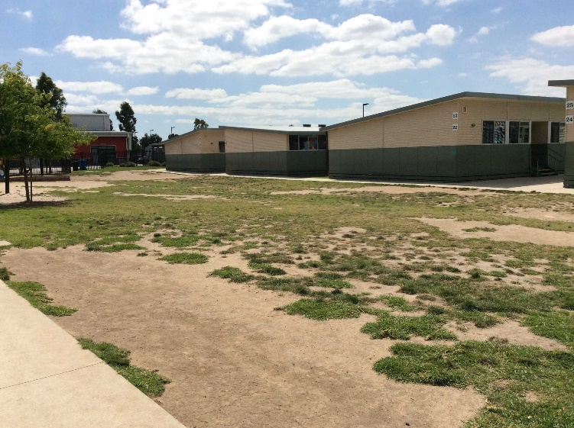

Good drainage and landscaping has helped erosion issue, as well as artificial turf used instead of grass.

High traffic area prep playground showing bad erosion from high population of students.

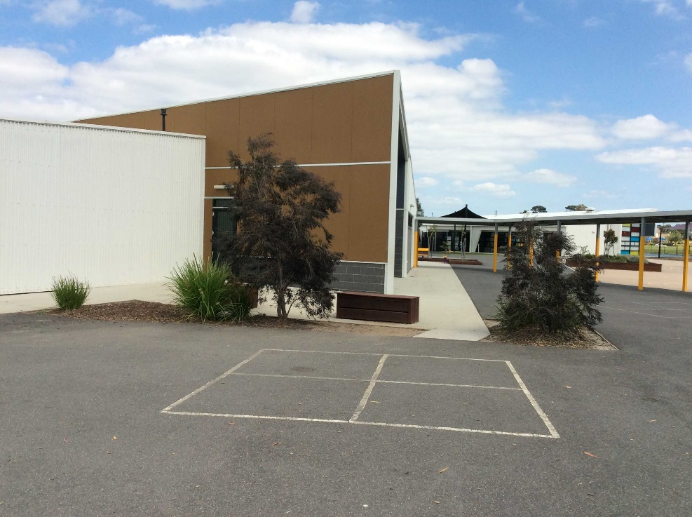

New pathway through garden to fix erosion.

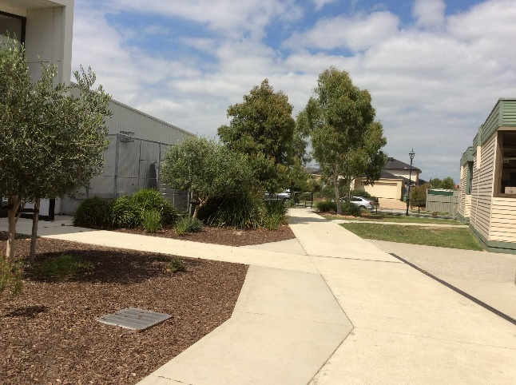

Garden growing well.

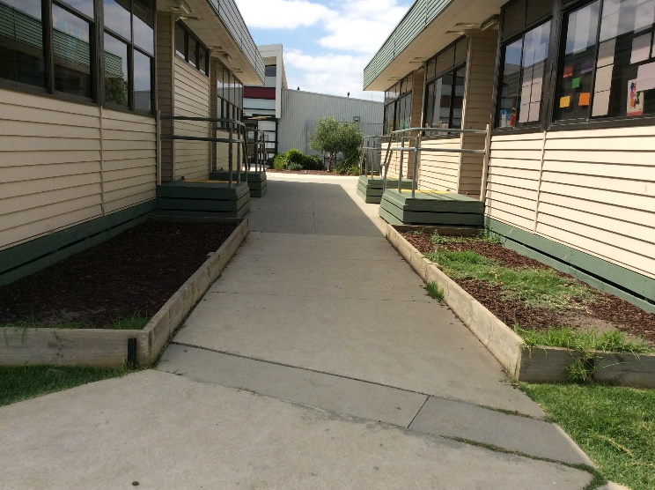

New gardens have been difficult to extablish in this area but we just keep trying different plants.

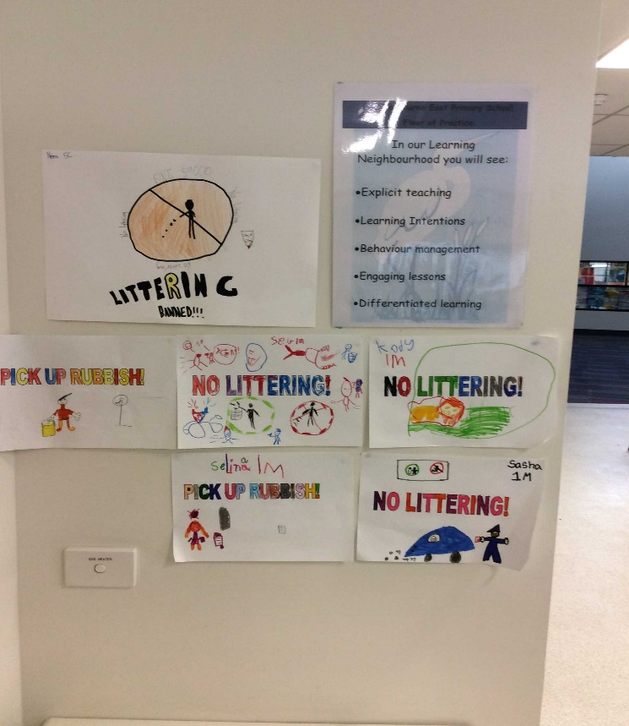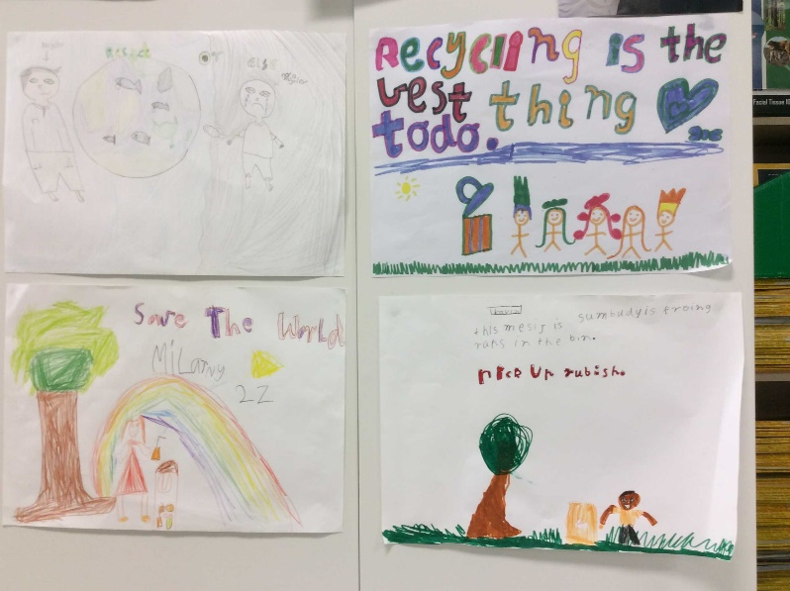

Students love designing and making Clean up Australia day posters and recycling posters.