VSGA EVENT REGISTRATION FORM
VSGA in partnership with The Patch Primary School presents:
“Nature Based Education: Challenges and Opportunities for Student Learning”
Interest in school garden projects and landscape restoration has increased rapidly in recent years. How do schools ensure such projects are genuinely student owned, sustainable (ecologically and financially)and nurture the school community?
Join leading environmental educator Michelle Rayner and Basil Natoli (VSGA), along with John Rayner (University of Melbourne), Richard Bellemo (Landscape Designer RB Landscapes) and community leaders in an exciting day to discover how nature based education can provide opportunities for student voice and engagement. Learnhow to:
- integrate nature based education into the national curriculum
- use school grounds to implement habitat restoration projects
- attract and sustain community involvement
- create living structures for the garden (green walls and roofs), propagate and use succulents in creative ways, keep wildlife in schools and link gardens and children with special needs.
When:Friday 24 October, 2014, 9.30 – 4.00 (student tours from 8.30 – 9.30)
Where: The Patch Primary School, Kallista-Emerald Road, The Patch
Cost: $85 (incl GST )incl. refreshments and lunch (wood fire pizza and soup)
The Patch Primary School has received multiple awards for its garden landscape, environmental education program and school habitat. Its 10 acres of grounds support wetlands, productive gardens, food forests, living sculpture, a maze, pizza oven and more. Come along and be inspired!

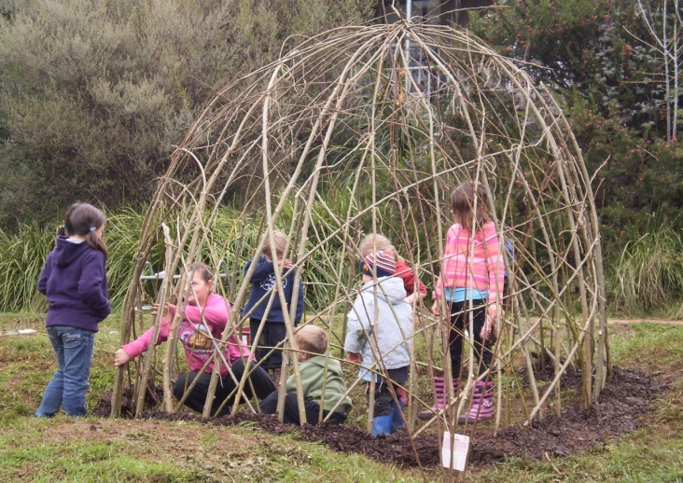
Places are limited. To book your place, please complete this form and return by Monday 20th October to:
Victorian Schools Garden Awards Coordinator
Email: sga@ngiv.com.au
Fax: 03 9576 0431
Address: PO Box 2280, Wattletree Road LPO, East Malvern 3145
Queries regarding the day to Michelle Rayner 9756 7463; rayner.michelle.t@edumail.vic.gov.au
REGISTRATION FORM
CONTACT DETAILS:
These details will be used to invoice your school for payment. Please ensure you have included the correct postal details.
Contact name:
School:
Address:
Suburb: |  | Postcode:
Phone:
Email:

PARTICIPANT DETAILS:
Please include names of all participants that you would like to register for this event.
Number of people you would like to register for this event:
Names of participants:

Dietary Requirements
INVOICE DETAILS:
Once received, your booking will be confirmed and an invoice posted for payment via cheque or electronic funds transfer.
Total invoice amount (No. of participants x $85):

Purchase order number (if applicable):

